Product Backlog



# **1. Product Backlog**

## **1.1. User Story Map**

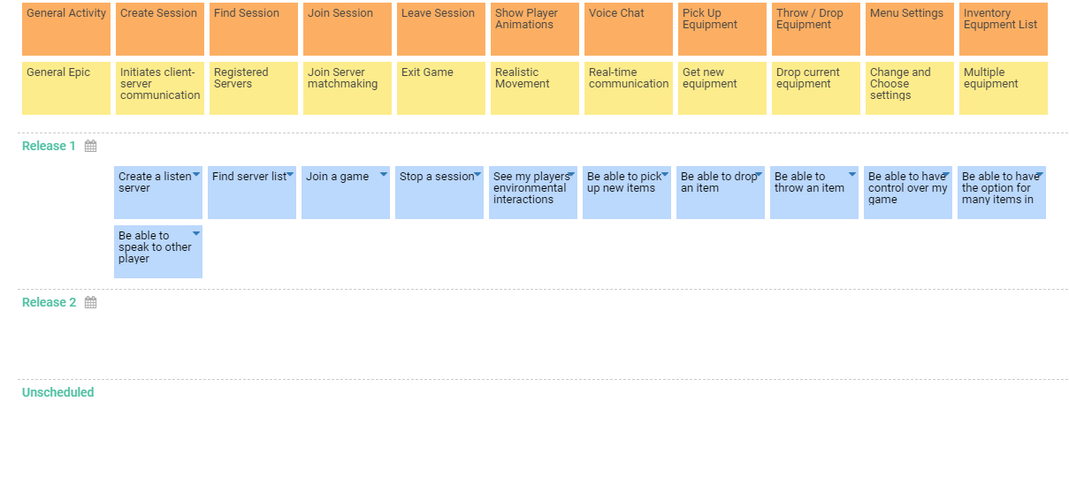

## **1.2. Prioritized User Stories**

| **ID** | **Name** | **Description** | **Epic** | **Status** | **Acceptance Criteria** | **Story Points** | **Priority** | **Risk** | **Split From** | **Due Date** |
| --- | --- | --- | --- | --- | --- | --- | --- | --- | --- | --- |
| US001 | Create a listen server | As a Server, I want to create a listen server so that other players can join. | Initiates client-server communication | Approved |  | 1 | Must | Low |  |  |
| US002 | Find server list | As a User, I want to join a game so that i can play. | Registered Servers | Approved |  | 1 | Must | Low |  |  |
| US003 | Be able to speak to other player | As a Player, I want to be able to speak to other player so that i can interact with them. | Initiates client-server communication | Approved |  | 8 | Must | High |  |  |
| US004 | Stop a session | As a player, I want to stop a session so that i can quit a game. | Exit Game | Approved |  | 1 | Must | Low |  |  |
| US005 | Join a game | As a player, I want to join a game so that i can play. | Join Server matchmaking | Approved |  | 1 | Must | Low |  |  |
| US006 | See my players environmental interactions | As a player, I want to see my players environmental interactions so that enjoy realism. | Realistic Movement | Approved |  | 5 | Must | High |  |  |
| US007 | Be able to pick up new items | As a player, I want to be able to pick up new items so that i can interact with them. | Real-time communications | Approved |  | 3 | Must | Medium |  |  |
| US008 | Be able to drop an item | As a player, I want to be able to drop an item so that free my invetory. | Get new equipment | Approved |  | 1 | Must | Low |  |  |
| US009 | Be able to throw an item | As a player, I want to be able to throw an item so that i can make a distraction or lit the enviroment with a flare. | Drop current equipment | Approved |  | 3 | Should | Medium |  |  |
| US010 | Be able to have control over my game | As a player, I want to be able to have control on my game so that enjoy it. | Change and Choose settings | Approved |  | 3 | Must | Medium |  |  |
| US011 | Be able to have the option for many items in my bag | As a player, I want to be able to have the option for many items in my bag so that i can have many options defeating the game. | Multiple equipment | Approved |  | 3 | Must | Medium |  |  |